Removing school.teacher03 (specific user from the system)

/home/users/H/Hn69k7CIIOHEjG7HYV9q/.tokens/18790eff-7b0b-4909-9852-9c40389e6d52

.

Upload excel file and delete

After deletion user and token no longer there

Login back again to aem and view user admin

User is created in a new path and token is displayed

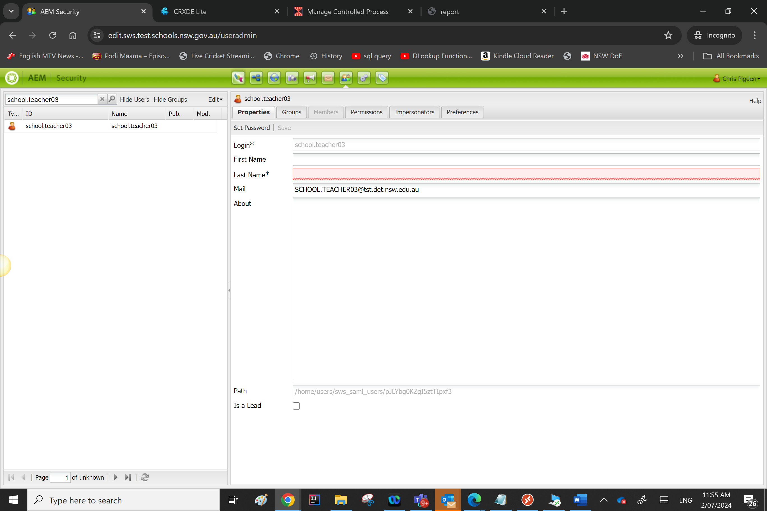

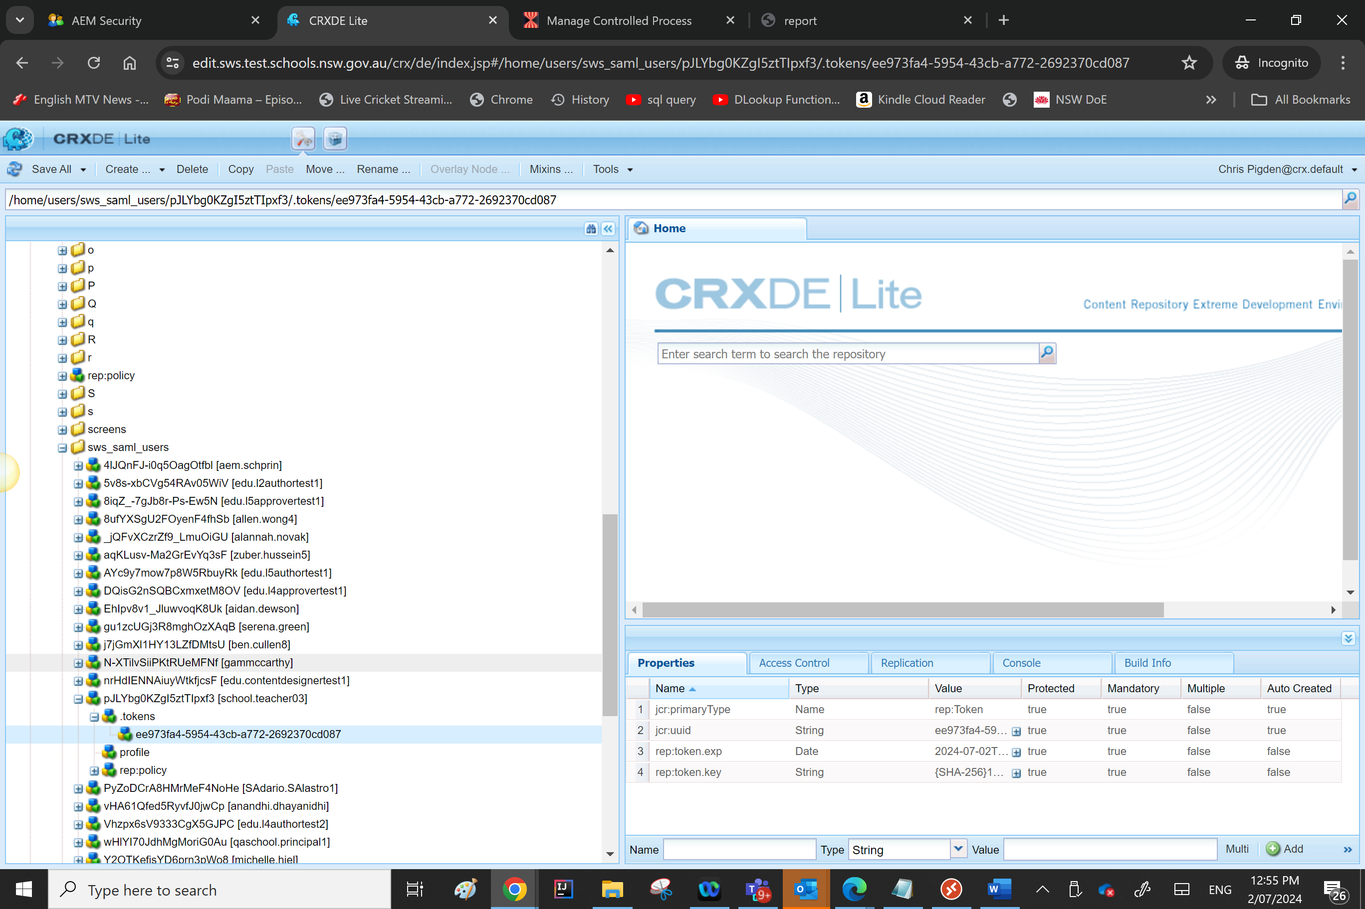

If the same path is used to remove again now that is null system will give the following error

If any of the token doesn’t meet the query criteria then the report will display that the user was not removed because rep:token.exp property that is later than the set minimum date

Eg:-  
school.teacher03 would NOT have been removed because it has a login token with a rep:token.exp property that is later than the set minimum date of Tue Jul 02 10:11:58 AEST 2024.

